Elizabeth Pavlik
WRTG 393 6386

How to Order Chinese-American Entrees from Mai Dragon

Mai Dragon is a restaurant serving Chinese and Cantonese dishes as well as dim sum to the Severn, Odenton, Fort Meade, and Jessup areas of Maryland. Mai Dragon is conveniently located just off MD-175 in the Ridgeview Plaza Shopping Center. Customers can expect quality food and generous portions at reasonable prices. It is a particular favorite of active duty personnel, civilian employees, and military families stationed at Fort Meade, and is located just outside the Rockenbach gate.

Mai Dragon has a convenient website with an easy-to-navigate interface. You can customize your entrees with the meat or vegetarian protein option of your choice, add extra protein, or even add a note with special instructions for the kitchen, such as allergy information. Both pickup and delivery are available as options for receiving your food, and you may pay either at the point of order or in person. You may even schedule your pickup for a future time if desired.

The following instructions will show you how to order a Chinese-American full-sized entree or lunch combo for pickup online at Mai Dragon.

1. Navigate to the Mai Dragon website at https://www.maidragon.com/.

2. Enter the online ordering portal by selecting one of the Order Online links on the homepage.

Figure 1
Order Online Links on Mai Dragon Homepage
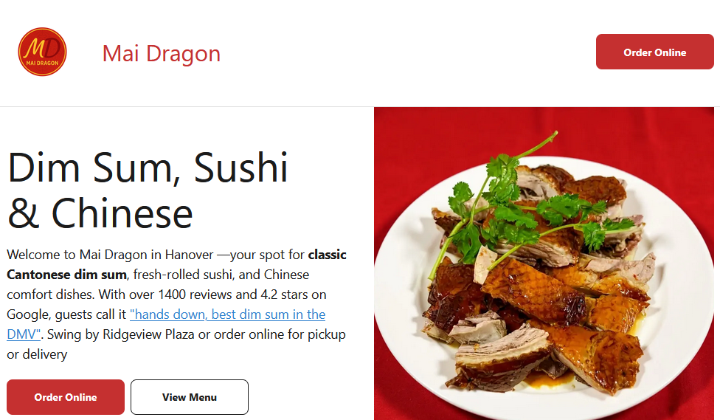
3. Select the pickup time for your order.

a. If you wish to pickup immediately, no changes are necessary.

Figure 2
Option to Pickup Order ASAP
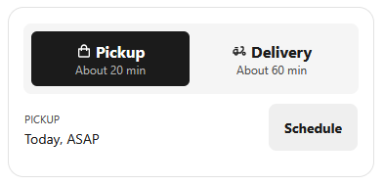

b. If you wish to change the pickup time, select the Schedule button and choose your desired pickup time from the popup that appears.

Figure 3
Option to Schedule Pickup Time
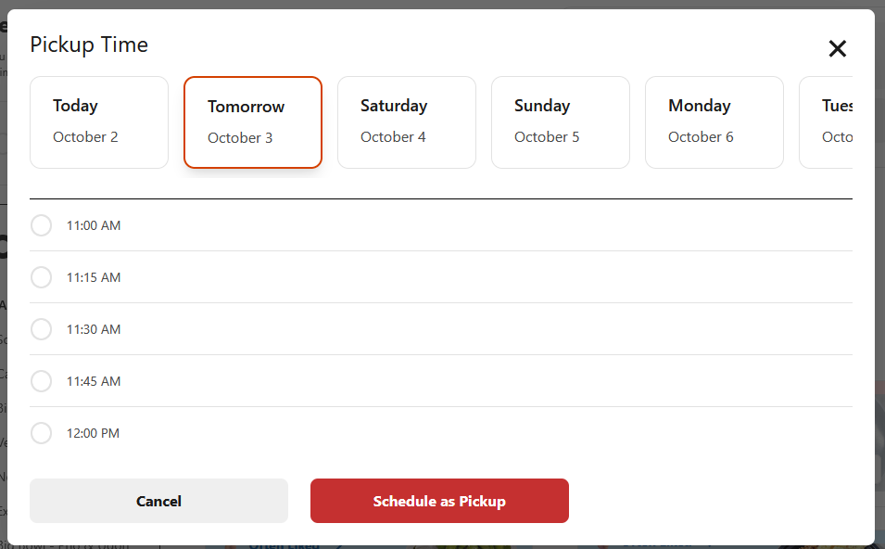

4. Select Chinese Menu at left, then select Big Plate.

Figure 4
Big Plate Selection on Chinese Menu
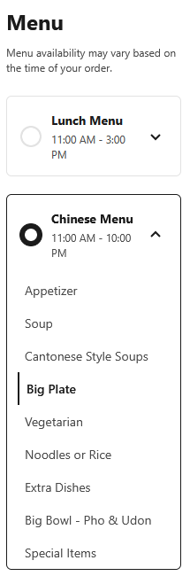

Note: If you would like the Lunch Combo instead, select Lunch Combo from the Lunch Menu at left. This menu is only available from 11 AM – 3 PM daily.

Figure 5
Lunch Combo Selection on Lunch Menu
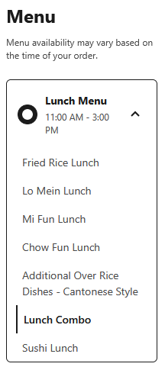
5. Select your preferred dish. Many of these options are available for the Lunch Combo as well.

Figure 6
Big Plate Entree Options
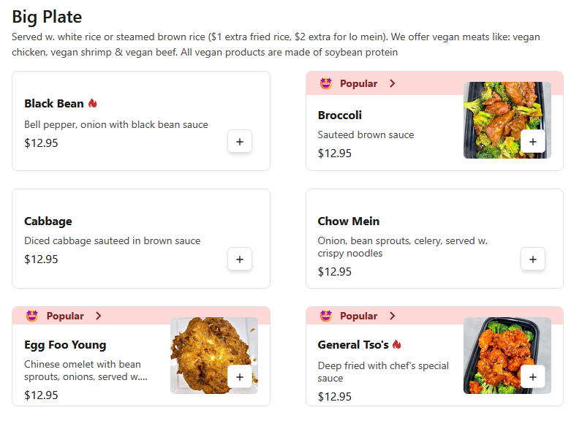

For example, the Mongolian entree is chosen.

Figure 7
Mongolian Entree with Options
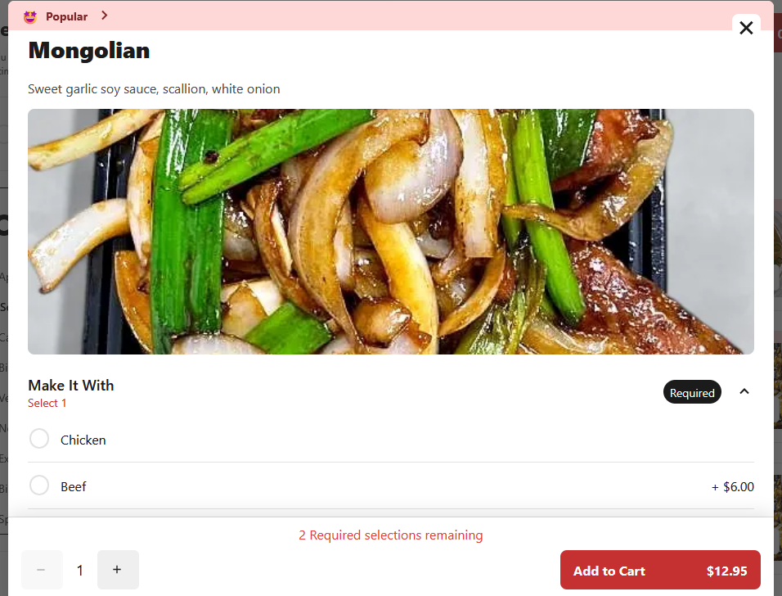

6. Choose the desired protein and rice type (required), as well as optional extra protein, sides, and special instructions. In this case, we have chosen beef as our protein and white rice.

Figure 8
Protein Selection
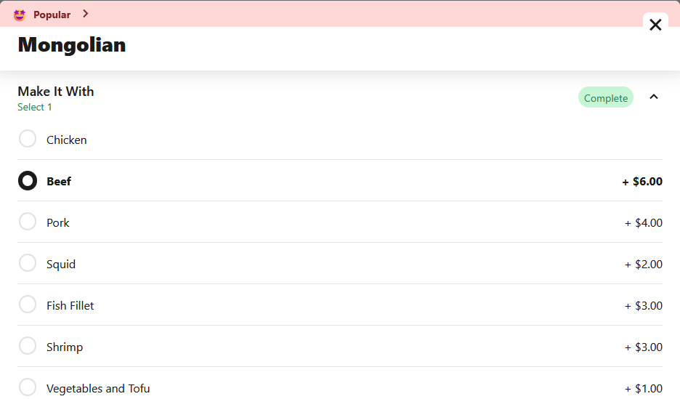

Figure 9
Rice Selection
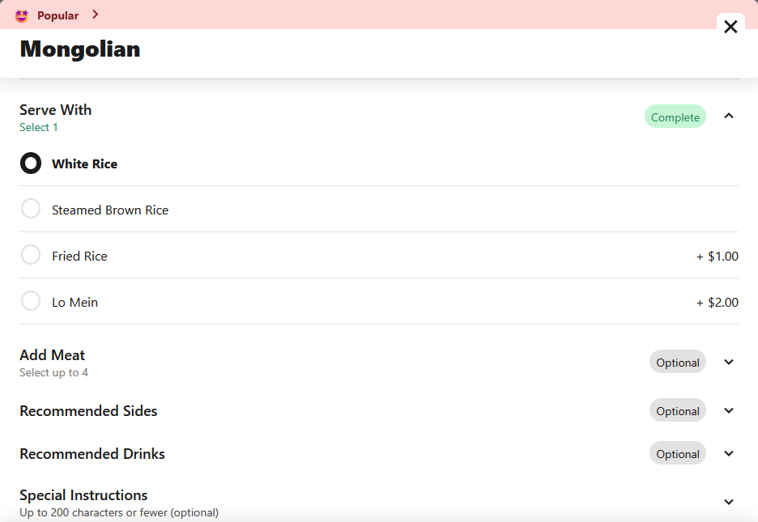
7. Adjust the quantity if desired by selecting the plus button.

Figure 10
Quantity Adjustment
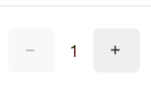
Note: This adds multiple entrees with the same options selected in Step 6.

8. Select the Add to Cart button when you are finished customizing your entree.

Figure 11
Add to Cart Button
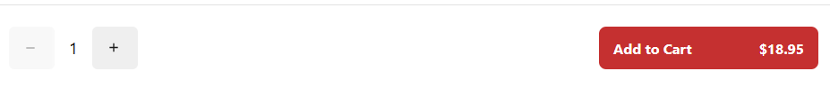

9. If you are finished adding items, select the cart button at top right, then the Checkout button.

Figure 12
Button to Access Cart
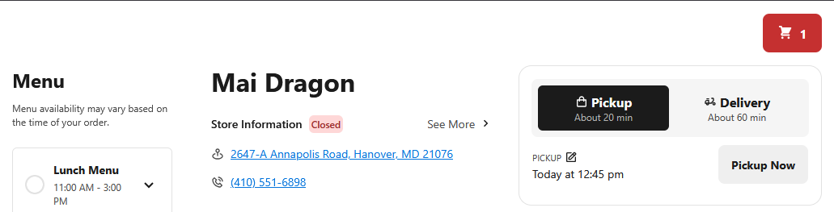

Figure 13
Checkout Button
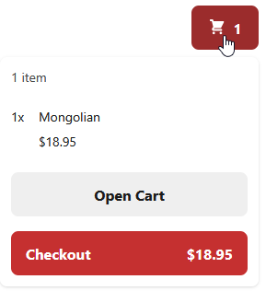

10. Choose whether you will Pay Now or Pay at Store.

a. If you wish to Pay Now, enter your credit card number, expiration date, CVC security code, country, and zip code.
Note: If you select Pay Now, a credit card is required.

Figure 14
Pay Now Required Information
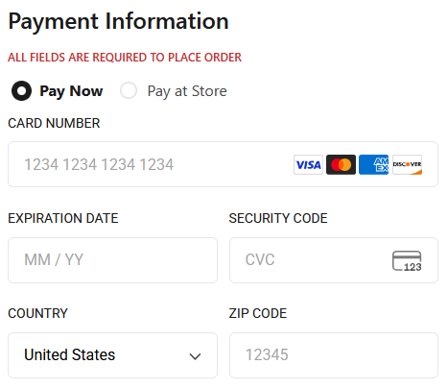

b. If you wish to Pay at Store, you may pay using cash or credit card when you pick up your order.
Note: As a safeguard against fraudulent orders, you must verify your phone number, entered in the next step.

Figure 15
Pay at Store Required Information
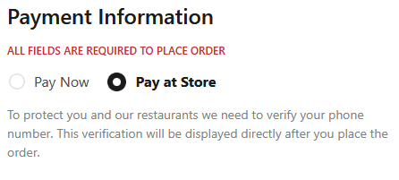
11. Enter your name, email address, and phone number. If you wish to receive an email notification of your order, select Email under Order Notifications.

Figure 16
Personal Information
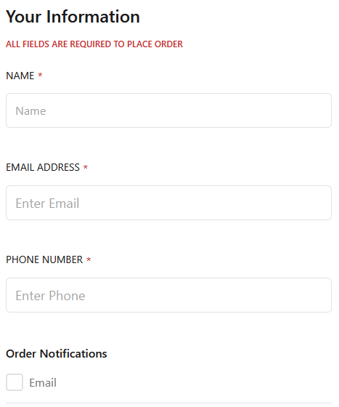
12. Enter any specific instructions to the restaurant regarding your order if desired.

Figure 17
Order Instructions Field
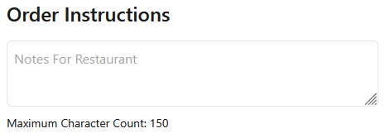

13. If you selected Pay Now in Step 10, you may enter a tip if desired.

Figure 18
Tipping Options
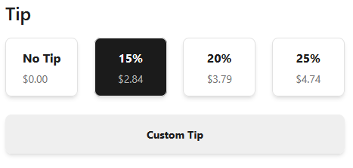

14. Review your order. Once you are satisfied, select the Place Order button to submit.

Figure 19
Place Order
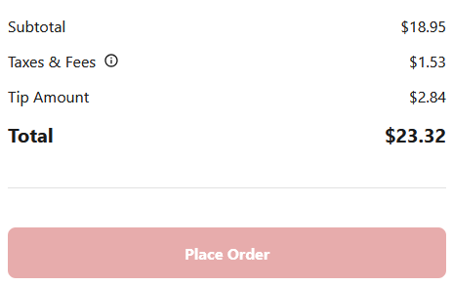

If you selected Pickup ASAP, your order will be ready at the displayed time on the confirmation page, generally 20 minutes after the order is placed. If you opted to pickup at a scheduled time, please ensure that you arrive at the restaurant at the time you selected.

Your meal will be waiting for you at Mai Dragon, 2647-A Annapolis Rd, Hanover, MD 21076.

For questions, please call the restaurant at (410) 551-6898.

References

Mai Dragon. (n.d.-a). Order online links on Mai Dragon homepage [screenshot]. https://www.maidragon.com/

Mai Dragon. (n.d.-b). Option to pickup order ASAP [screenshot]. https://www.maidragon.com/42tys97v/mai-dragon-hanover-21076/order-online?menu=Lunch+Menu

Mai Dragon. (n.d.-c). Option to schedule pickup time [screenshot]. https://www.maidragon.com/42tys97v/mai-dragon-hanover-21076/order-online?menu=Lunch+Menu

Mai Dragon. (n.d.-d). Big plate selection on Chinese menu [screenshot]. https://www.maidragon.com/42tys97v/mai-dragon-hanover-21076/order-online?menu=Chinese+Menu&category=Big+Plate

Mai Dragon. (n.d.-e). Lunch combo selection on lunch menu [screenshot]. https://www.maidragon.com/42tys97v/mai-dragon-hanover-21076/order-online?menu=Lunch+Menu&category=Lunch+Combo

Mai Dragon. (n.d.-f). Big plate entree options [screenshot]. https://www.maidragon.com/42tys97v/mai-dragon-hanover-21076/order-online?menu=Chinese+Menu&category=Big+Plate

Mai Dragon. (n.d.-g). Mongolian entree with options [screenshot]. https://www.maidragon.com/42tys97v/mai-dragon-hanover-21076/order-online?menu=Chinese+Menu&category=Big+Plate

Mai Dragon. (n.d.-h). Protein selection [screenshot]. https://www.maidragon.com/42tys97v/mai-dragon-hanover-21076/order-online?menu=Chinese+Menu&category=Big+Plate

Mai Dragon. (n.d.-i). Rice selection [screenshot]. https://www.maidragon.com/42tys97v/mai-dragon-hanover-21076/order-online?menu=Chinese+Menu&category=Big+Plate

Mai Dragon. (n.d.-j). Quantity adjustment [screenshot]. https://www.maidragon.com/42tys97v/mai-dragon-hanover-21076/order-online?menu=Chinese+Menu&category=Big+Plate

Mai Dragon. (n.d.-k). Add to cart button [screenshot]. https://www.maidragon.com/42tys97v/mai-dragon-hanover-21076/order-online?menu=Chinese+Menu&category=Big+Plate

Mai Dragon. (n.d.-l). Button to access cart [screenshot]. https://www.maidragon.com/42tys97v/mai-dragon-hanover-21076/order-online?menu=Chinese+Menu&category=Big+Plate

Mai Dragon. (n.d.-m). Checkout button [screenshot]. https://www.maidragon.com/42tys97v/mai-dragon-hanover-21076/order-online?menu=Chinese+Menu&category=Big+Plate

Mai Dragon. (n.d.-n). Pay now required information [screenshot]. https://www.maidragon.com/42tys97v/mai-dragon-hanover-21076/checkout

Mai Dragon. (n.d.-o). Pay at store required information [screenshot]. https://www.maidragon.com/42tys97v/mai-dragon-hanover-21076/checkout

Mai Dragon. (n.d.-p). Personal information [screenshot]. https://www.maidragon.com/42tys97v/mai-dragon-hanover-21076/checkout

Mai Dragon. (n.d.-q). Order instructions field [screenshot]. https://www.maidragon.com/42tys97v/mai-dragon-hanover-21076/checkout

Mai Dragon. (n.d.-r). Tipping options [screenshot]. https://www.maidragon.com/42tys97v/mai-dragon-hanover-21076/checkout

Mai Dragon. (n.d.-s). Place order [screenshot]. https://www.maidragon.com/42tys97v/mai-dragon-hanover-21076/checkout

How the Personas Were Accommodated

Amy Howard wants to order a black pepper chicken entree with brown rice for immediate pickup, paid by credit card in the store. Mike Setliff wants a lunch combo broccoli with beef, scheduled for pickup at 12:45 PM, and wants to pay with cash. Connie Trevino wants to order two entrees with vegetarian or vegan proteins, white rice with one and brown rice with the other, and wants to pay online with her credit card.

Step 3a shows Amy how to ensure that her pickup time is set to ASAP. Step 3b shows Mike and Connie how to schedule their order pickup for future times.

All three are accommodated by Step 4, which shows the location of the Big Plate entrees menu for Amy and Connie and the Lunch Combo menu for Mike.

Step 8 explains how to choose the required protein and rice options for the entrees, which is a relevant task for Amy, Connie, and Mike.

From Step 10a, Connie learns how and where to enter her credit card information for the Pay Now option. Amy and Mike can refer to Step 10b, which explains how to verify their phone numbers and to ensure that they can use either cash or credit upon pickup in store.

If Connie wishes to tip using her credit card, she can refer to Step 13 to learn how to do so.

